STAGE 1 DROUGHT

Our water system is under Stage 1 water-use restrictions as of June 21, 2018. This announcement will be designed to increase customer awareness of water conservation and encourage the most efficient use of water.

VOLUNTARY WATER USE RESTRICTIONS
Water customers are requested to voluntary limit the use of water for nonessential purposes and to practice water conservation.

General Water Conservation Tips
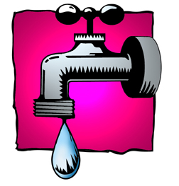
- Install water-efficient appliances and fixtures. A leaky toilet can waste 200 gallons of water per day, and it is estimated that nearly 20 percent of all toilets leak. To test, add a few drops of food coloring or a dye tablet to the water tank, but do not flush the toilet. Watch to see if the coloring appears in the bowl within a few minutes. If it does, the toilet has a silent leak that needs to be repaired. Design a water-efficient landscape by planting drought-tolerant grass and choosing plants that are native or well adapted to the climate conditions in your area.
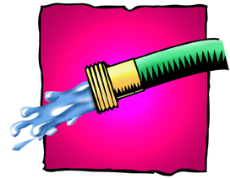
- Limit your yard watering to no more than once a week, and prevent water evaporation by watering early in the morning --- and never on windy days. Adding rain sensors on your irrigation system will keep you from watering your yard unnecessarily during or after a rain.

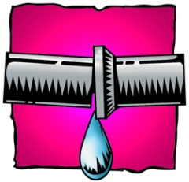
- Check for hidden water leakage such as a leak between the water meter and the house. To check, turn off all indoor and outdoor faucets and water-using appliances. The water meter should be read a 10 to 20 minute intervals. If the reading on the meter changes while faucets and water-using appliances are turned off then a leak probably exists and should be fixed. Remember, not all leaks will reach the surface. This is due to the fact that the leaks are relatively small and there isn’t enough pressure to force the water to the surface. Normally, water will dissipate into the ground and find “the path of least resistance” which is typically down – not up.

